Clockwork Online Forms – Student

- Sign in to myAIMS. Click on the Online Forms button.
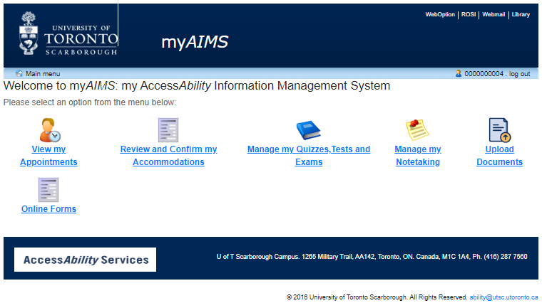

- Select ‘Fill in this form’ button, the form will be open.
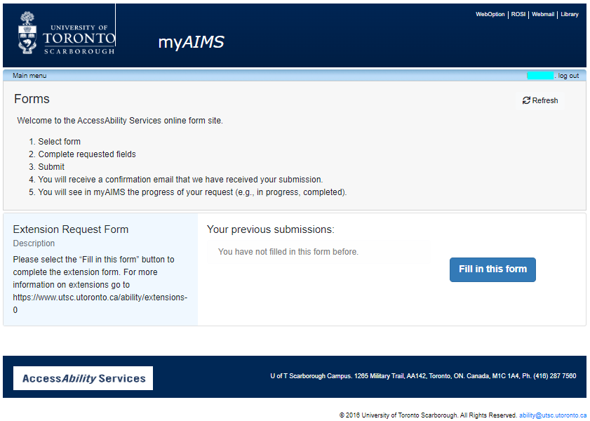
- The form will open for completion and submission

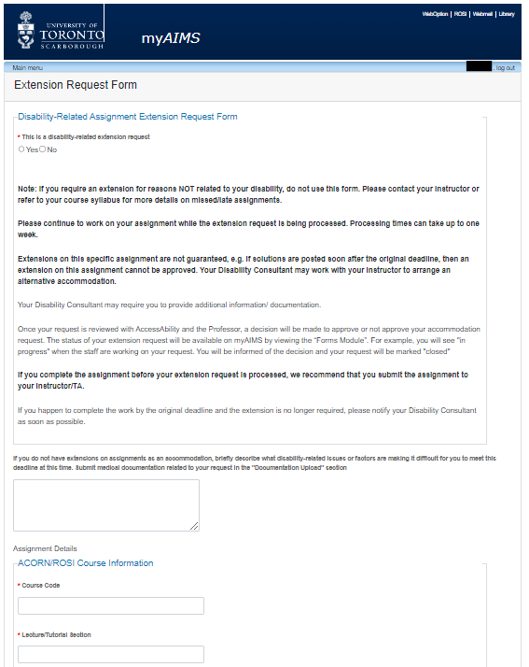

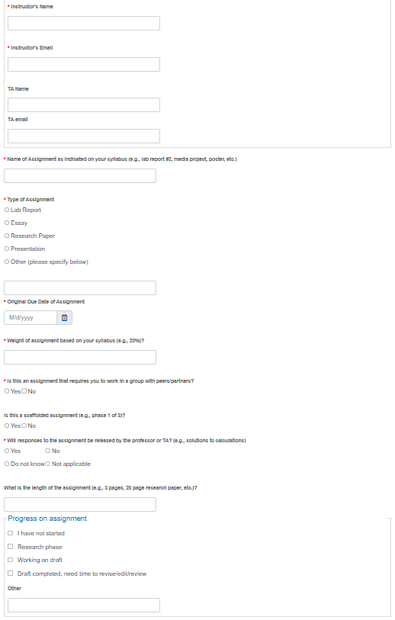

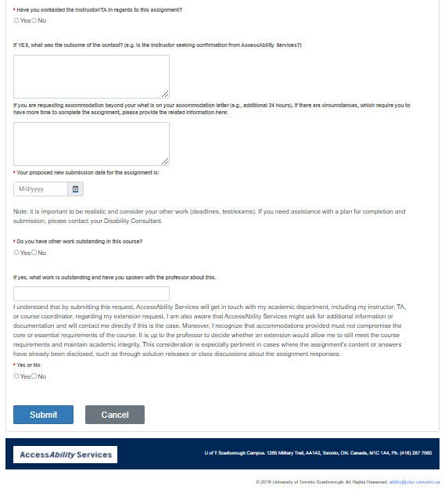
- After your form is submitted you will be able to check on the status under your previous submissions.
