# UTSCsignature.eps

# Outreach Team Volunteer Role Description

Access*Ability* Services

**Title/Position:** Access*Ability* Outreach Team Volunteer

**Goal of Position**:

The Outreach Team plays integral role in supporting Access*Ability* Services to reach out to the University of Toronto Scarborough community and build awareness about Access*Ability* Services and the Peer Note Taking program. Outreach volunteers will assist the department in recruiting volunteer Note Takers through various outreach activities. Successful recruitment efforts by volunteers will ensure that students with disabilities receive this accommodation in a timely manner.

**Other Activities:**

Under the direction of the Coordinator, Volunteer Resources, Outreach volunteers will assist Access*Ability* Services in one or more of the following areas:

1. Display booths: Volunteers will lead Access*Ability* Services display booths by providing general information to the university community regarding the service and the Note Taking program. Volunteers will take initiative to approach students, inform them of the need for volunteer Note Takers and recruit students to become potential volunteer Note Takers.

1. In-Class Announcements: Volunteers will assist Access*Ability* Services in making announcements in the classes that require Note Takers. Announcements are usually made in the first few minutes of the class time, before the lecture begins.
2. Personal Support Assistant: Volunteers will work one-on-one assisting students with disabilities in their activities on campus. These can include, assisting students in lectures and assistance students with mobility on campus.
3. Other: Volunteers will also have the opportunity to assist with outreach events and with general office support. Office support includes (and is not limited to): photocopying & assembling professor packages and general office forms.

Length of Commitment:

**Summer**

May – August

and/or

**Fall / Winter**

September - April

Schedule:

Volunteers will be scheduled according to their availability and the needs of Access*Ability* Services.

**Work site:**

Various locations within UTSC

**Skills Sought:**

1. Good interpersonal skills
2. Strong communication skills
3. Interest in disability-related issues

**Benefits:**

1. Active contribution to the UTSC peer community
2. Opportunity to lead student campaigns, increase awareness on disability related issues and gain valuable leadership experience
3. Build your resume
4. Recognition on the Co-Curricular Record

**Number of Vacancies:** 25

**To Apply:**

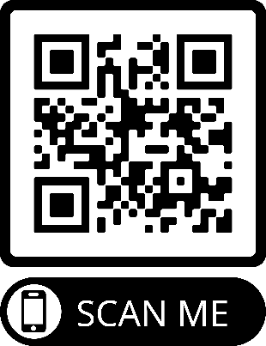

Complete the Outreach Team Volunteer Application Form and submit your application in person or via email to: [Kristina.Stanley@utoronto.ca](mailto:Kristina.Stanley@utoronto.ca)

Kristina Stanley

Volunteer Resources, Accommodations Coordinator

Access*Ability* Services

AA 142

Access*Ability* Services thanks you for your interest. All applicants who meet our criteria will be contacted.