Taking a Timed Exam in Quercus

- Open the course. In Course Navigation, click the "Quizzes" link.
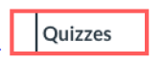
Figure 1 Quizzes link
- Find the Final Exam.

You should be able to see the day the exam opens and the due date of the exam.

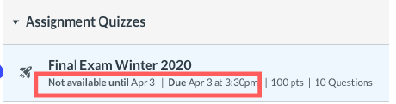
Figure 2 Quiz availability information

Click the exam to see its duration and the exact date/time it will open.

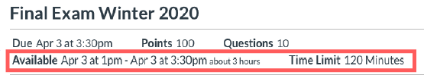
Figure 3 Quiz details

- Once the exam becomes available and you are ready to start, click Take the Quiz button to begin the exam.
Figure 4 Take the Quiz button

The time you started the exam will be displayed below the exam name.

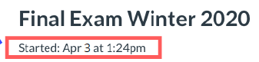
Figure 5 Time exam was started
The right sidebar will display the due date, and a timer that shows the running time and counts down until time expires.
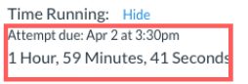
Figure 6 Exam due date and timer

Important: The browser will display a notification banner if you are not able to complete the exam in the full allotted time period. For example, if a 120-minute exam is available until 6:00 pm and you started at 5:00 pm, you will only have 60 minutes to complete the exam.
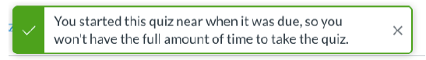
Figure 7 Notification if student will not have full quiz time

Your exam will auto-submit when the time is up even if you did not click the Submit button.
You will be warned 30 min prior, 5 minutes prior, 1 minute prior, and 10 seconds prior to auto submit.
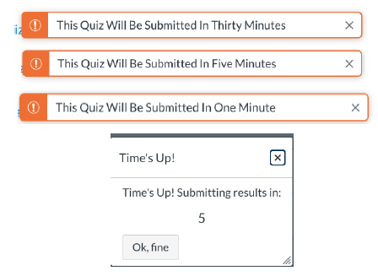
Figure 8 Notifications prior to auto-submit

