Submitting up a Take Home Exam in Quercus

- Open the course. In Course Navigation, click the "Assignments" link.
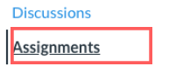
Figure 1 Assignments link

- If the Exam is not yet available you will see it under Upcoming Assignments. You will not be able to view or submit the exam except on the date and time specified.

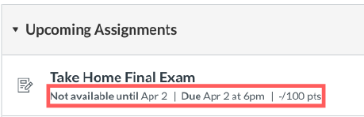
Figure 2 Exam availability date

Click the exam to see the exact time it will be open for submission.

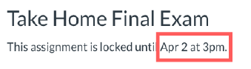
Figure 3 Exam availability date/time

- Once the exam becomes available you will see the
- Exam Due date
- Accepted file types
- Exam availability and duration

You will also be able to see the exam instructions. Click the Submit Assignment button when you are ready to submit the exam.

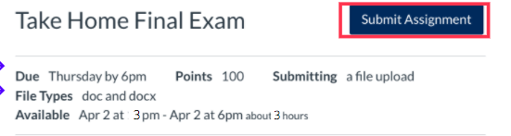
Figure 4 Submit assignment page

- The File Upload box should appear.

Click Choose File to upload a file from your computer.

If you need to upload another file, click the Add Another File link.

Enter any comments if needed. Click the Submit Assignment button to submit your file(s).

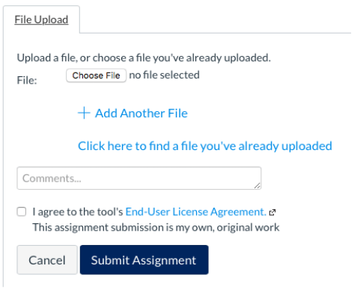
Figure 5 Upload assignment file

- You should see the confirmation of your exam submission.

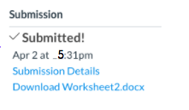
Figure 6 Confirmation of submission

